**Project Documentation**

**Assignment**

Abrar Alotaibi

Introduction: 3

1. Website development: 3

1.1 Technologies Used: 3

1.2 Functionality: 3

1.3 Implementation: 3

1.4 User Interface: 4

2. Application: 5

2.1 Technologies Used: 5

2.2 Functionality: 5

2.3 Implementation: 5

2.4 User Interface: 5

GitHub repositories: 6

Conclusion: 6

## 

## **Introduction**:

This documentation on the website development and application. The website is built using PHP/MySQL for the backend and HTML/CSS/JS for the frontend. The application is developed using Flutter framework with Riverpod state management. Both applications retrieve data from a common backend and display it in a list format.

## Website development:

## Technologies Used:

* **PHP:** language used for backend development.
* **MySQL:** Relational database management system for storing data.
* **HTML:** Markup language for structuring the web page.
* **CSS:** Style Sheets for styling the web page.
* **JavaScript (JS):** Programming language used for to add functionality to web pages.

## Functionality:

* The website allows users to create and display a list of data.
* Data fields include name, email, and phone number.
* Users can enter the data through a form, which is then stored in the MySQL database.
* The stored data is retrieved from the database and displayed on the webpage.

## Implementation:

1. **Frontend Development:**

* Use HTML to structure the webpage and create the form for data entry.
* Use CSS to style the webpage, ensuring an appealing and user-friendly interface.
* Use JavaScript for client-side validation and interactivity.

1. **Backend Development:**

* Use PHP connects to the MySQL database server at localhost with the provided username and password.



* Create MySQL Database . I'll use "saff_db" as the database name.
* Design database user_info table to store the data (name, email, phone number).

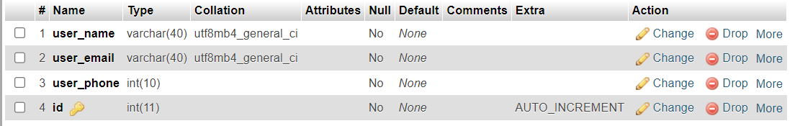

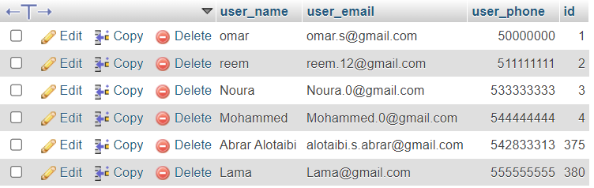

user_info data

* Implement PHP scripts to data insertion into the database and retrieval from it.

## User Interface:

## 

## Application:



## Technologies Used:

* **Flutter**: framework for mobile app development.
* **Dart**: Programming language used for developing Flutter apps.
* **Riverpod**: State management library for managing app state and data.

## Functionality:

- The Application fetches the same data from the PHP backend using JSON APIs.

- The retrieved data is then displayed in a list.

## Implementation:

- Use Flutter framework to develop the mobile app.

- Use Dart programming language to write the app's logic and UI components.

- Install and configure Riverpod state management library for managing app state.

- Use HTTP package to make API requests to the PHP backend.

- JSON response and convert it into List for display in the app.

- Design the app's user interface (UI) using Flutter widgets and components.

- Display the fetched data.

## User Interface:

## GitHub repositories:

Link : <https://github.com/orgs/assignment-SAFF/repositories>

## Conclusion:

This project documentation provided an overview of assignment for a Website and Application. The Website was built using PHP/MySQL for the backend and HTML/CSS/JS for the frontend. The Application was developed using Flutter framework with Riverpod state management.